Machine Learning with Big data Project

Goutam Bhattacharya (M25DE1029)
Abhirup Ghosh (M25DE1073)
Github Link: https://github.com/Tirtho-69420/MLBD_Project

Large-Scale Sentiment Analysis of Social Media Data Using Apache Spark
- Introduction
With the rapid growth of social media platforms, massive volumes of textual data are generated daily. Analyzing this data helps organizations understand public opinion, customer satisfaction, and emerging trends.
This project focuses on building a large-scale sentiment analysis system using Apache Spark (PySpark) to process millions of tweets efficiently and classify them into positive or negative sentiments.
- Objectives

- To process large-scale social media data efficiently using distributed computing.
- To perform text preprocessing and feature extraction.
- To build and compare multiple machine learning models for sentiment classification.
- To evaluate model performance using appropriate metrics.
- To visualize insights such as sentiment distribution and frequent words.

- Dataset Description
The project uses the Sentiment140 dataset, which contains 1.6 million tweets.
Dataset Features:
Column | Description
sentiment | Target variable (0 = Negative, 4 = Positive)
id | Tweet ID
date | Timestamp
query | Query used
user | Username

- Technology Stack
- Apache Spark (PySpark) – Distributed data processing
- Python – Programming language
- Spark MLlib – Machine learning library
- Matplotlib – Data visualization
- Pandas – Data handling for visualization
- Methodology
5.1 Spark Initialization
- A Spark session is created to enable distributed data processing:
- Initializes Spark environment using findspark
- Creates a SparkSession for large-scale computation
5.2 Data Loading
The dataset is loaded using Spark’s CSV reader:
- Schema inferred automatically
- No header initially, then columns assigned manually
5.3 Data Preprocessing
Text Cleaning Steps:
- Convert text to lowercase
- Remove URLs
- Remove special characters
Label Transformation:
- Sentiment 4 → 1 (Positive)
- Sentiment 0 → 0 (Negative)
5.4 Feature Engineering
The text data is converted into numerical features using:
- Tokenizer
  - Splits text into words
- StopWordsRemover
  - Removes common words (e.g., "the", "is")
- Count Vectorizer
  - Converts words into numerical feature vectors
5.5 Train-Test Split
- Training Data: 80%
- Testing Data: 20%
- Random seed used for reproducibility
- Machine Learning Models

6.1 Logistic Regression
- A linear model for binary classification
- Efficient for large datasets
- Implemented using Spark ML pipeline
Pipeline Stages:
Tokenizer → StopWordsRemover → CountVectorizer → Logistic Regression

6.2 Naïve Bayes
- Probabilistic classifier based on Bayes’ theorem
- Works well with text data
Special Handling:
- Probability vector corrected using UDF to handle Spark edge cases

6.3 Random Forest
- Ensemble learning method using multiple decision trees
- Improves accuracy and robustness

- Model Evaluation

Evaluation Metrics Used:
- Accuracy
- F1 Score
Evaluators:
- BinaryClassificationEvaluator (for LR & NB)
- MulticlassClassificationEvaluator (for RF)

- Results
Model Performance Comparison (Example Format):
Model | Accuracy | F1 Score
Logistic Regression | High | Good
Naïve Bayes | Moderate | Moderate
Random Forest | Highest | Best

- Data Visualization
9.1 Sentiment Distribution
- Bar chart showing number of positive vs negative tweets
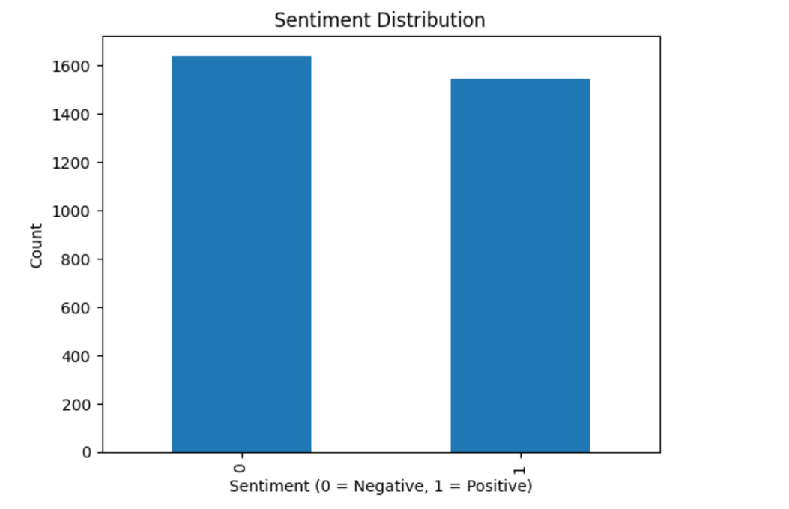
9.2 Frequent Words
- Top 20 most common words in tweets
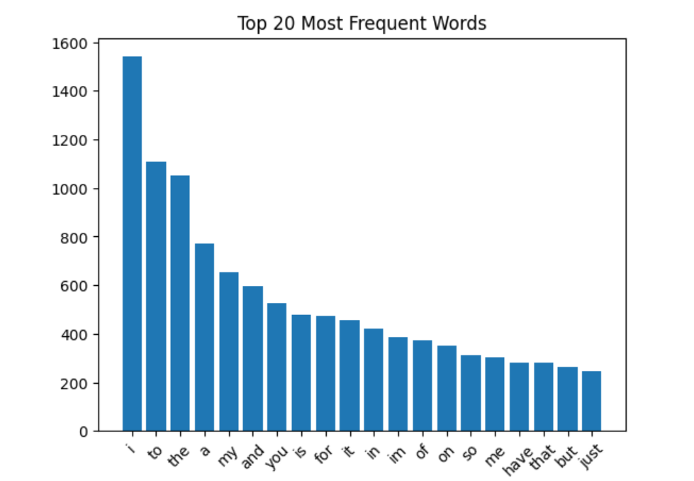
9.3 Bigram Analysis
- Most frequent word pairs (2-word combinations)
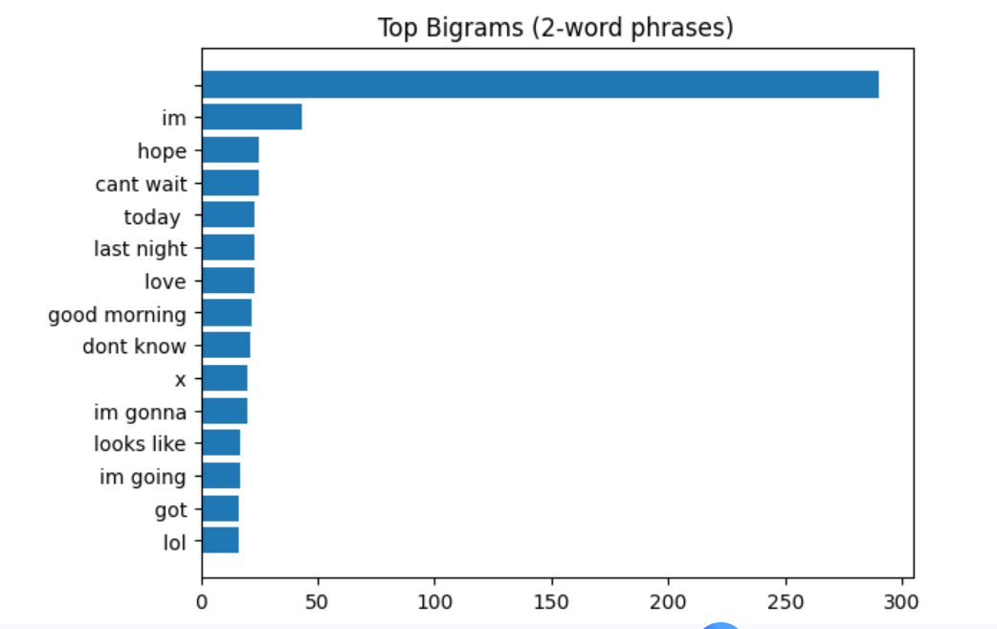

- Sample Predictions
Example inputs:
- “I love this product” → Positive
- “This is the worst experience ever” → Negative
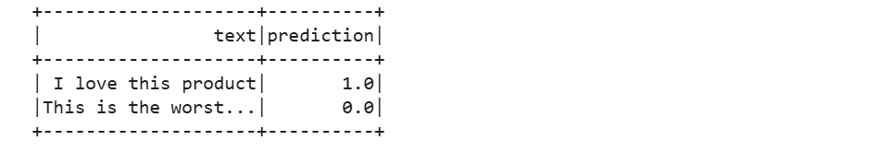
- Model Saving
- The trained Logistic Regression model is saved for future use:
- Key Insights

- Distributed computing enables processing of large datasets efficiently.
- Logistic Regression performs well for text classification tasks.
- Feature engineering plays a crucial role in model accuracy.
- Ensemble methods like Random Forest improve performance further.

- Challenges Faced
- Handling large dataset efficiently
- Cleaning noisy social media text
- Managing Spark probability vector issues
- Optimizing model performance

- Future Enhancements
- Use TF-IDF instead of CountVectorizer
- Implement Deep Learning models (LSTM, BERT)
- Perform real-time sentiment analysis using Spark Streaming
- Add neutral sentiment classification
- Deploy model as a web application

15. Conclusion
This project successfully demonstrates how Apache Spark can be used to build a scalable sentiment analysis system for large social media datasets. Multiple machine learning models were implemented and compared, showing that distributed ML pipelines can efficiently handle big data problems.

